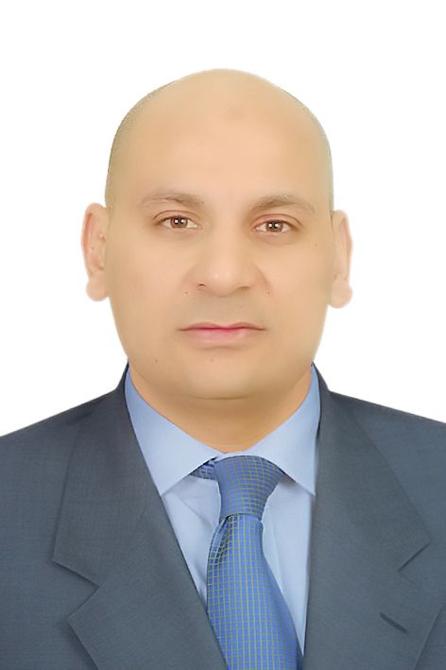

c.v

Moawad Mahmoud Moawad

1.PERSONAL DATA:

Date of Birth : 05/10/1978
Tel : 00201285249118 and 00201092166357
Nationality : Egyptian
E_mail : moawad_mody@yahoo.com
Place of Birth : Cairo
Military Service : finished
Driving license : 66335 Red Sea

2.BACKGROUND: EDUCATION:

Graduated from the Faculty of Tourism And Hotels management 2001 Cairo UN.

3.LANGUAGES:

Arabic : Mother language
English : excellent
Russian : excellent

4. COMPUTER Skills:

Familiar With The Following Programs:
- Windows,
- Microsoft Office.
- Internet Browsing.
- Hotels management system
- Excel Program

- EXPERIENCE:
- Front Office in Hotel Atlas Center Cairo (Front Office)
From 01/07/2001 till 14/04/2002.
- Hotels Representative (guiding) in Travel agency (EASTMAR TRAVEL) English and Russian.
From 01/05/2002 till 05/09/2004.
- Hotels Representative (guiding) in Travel agency (Travco Group)English and Russian.
From 14/10/2004 till 01/07/2006
- Hotels Representative (guiding) in Travel agency (TezTour) Russian language .
From 20/07/2006 till 23/07/2007.
- Hotels Representative in Travel agency (Intourist & Thomas cook) Russian language.
From 01/08/2007 till 15/10/2009.
6-Chief Tour Leaders In Turkish Travel Agency (Odion Tours )From 15/11/2009 Till 28/01/2014 Responsible for sales and everything concerning the guides .
7- Hotels Representative in Russian Travel Agency Biblio Globos from 10/02/2014 till now.

6-SKILLS & My Words .

1- Ability to Work under Pressure.
2-Ability to sell excursion and organize trips.
3-Excellent Communication Skills .

Finally : this is my experience and I hope to be one of your big staff and I hope to make a good profit to the company , thanks

Moawad Mahmoud.

